* **[How to change SharePoint branding text in the upper left part of your screen](https://sharepoint.rackspace.com/learning/articles/Pages/SharePoint-2013--How-to-change-SharePoint-branding-text-in-the-upper-left-part-of-your-screen.aspx)**

Companies frequently ask about the possibility of changing the word 'SharePoint' in the upper-left corner of the screen to better reflect their individual branding - here is how it's done:  
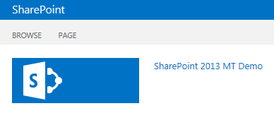  
  
1. **Open SharePoint Designer 2013**. (If you do not have SharePoint Designer 2013 a free download can be found here: [**http://www.microsoft.com/en-ie/download/details.aspx?id=35491**](http://www.microsoft.com/en-ie/download/details.aspx?id=35491))

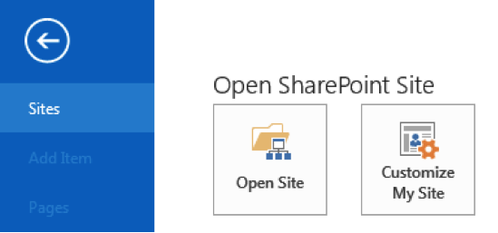

2. With SharePoint Designer 2013 open click **Open Site**.  
  
3. An Open Site window will appear. At the bottom in the Site name: section, type your SharePoint URL. (For this demo I will be using [**https://scuba3.atrackspace.com**](https://scuba3.atrackspace.com/))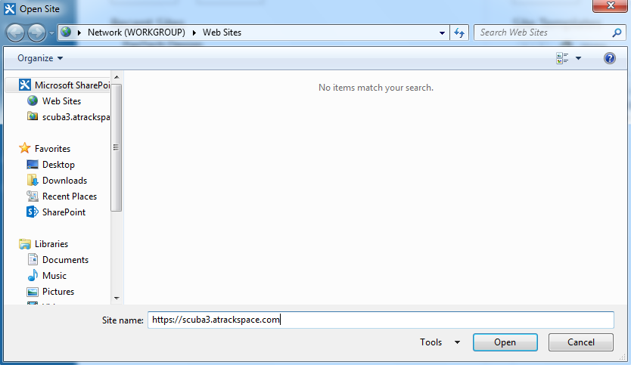

4. Click **Open**. (If you have never opened your site in SharePoint Designer 2013 the SharePoint login prompt will appear.  Click **Sign In to SharePoint** and enter your credentials.  You may receive an error, this is fine just click the red x to close the window and your site will open.)

5. In the left navigation click **Master Pages**.

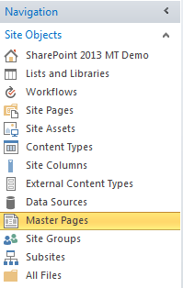

6. Click to the right of **seattle.master** to highlight it.

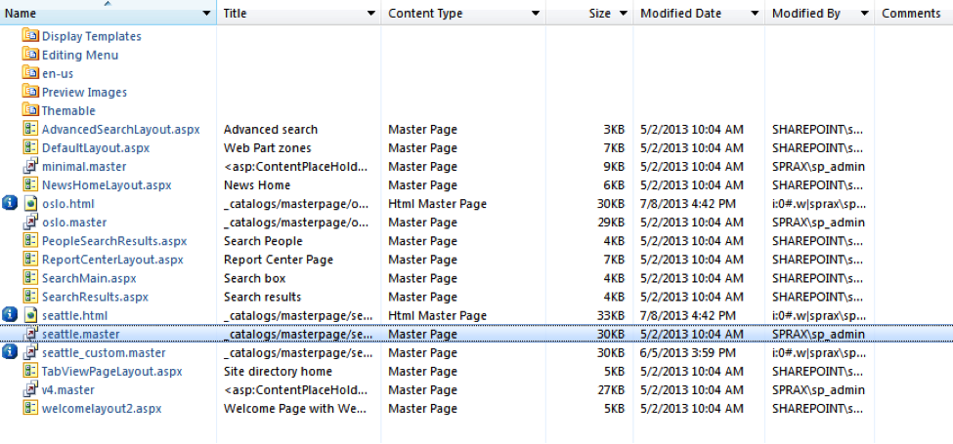

7. In the upper-left corner of the page, click **Copy**.

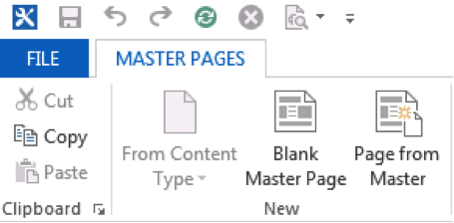

8. To un-highlight **seattle.master**, click below the last item on the page - in this example case the last item on the page is **welcomelayout2.aspx**.

9. In the upper left hand corner click **Paste**.

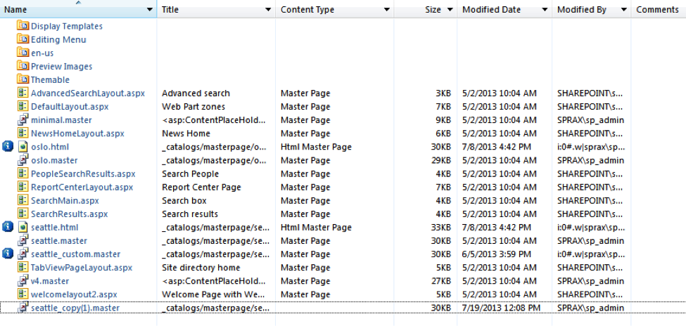

***You have now created a copy of the master page. You never want to edit the default master page in case you need to revert for any reason.***

10. Click the newly created master page **seattle_copy(1).master**.

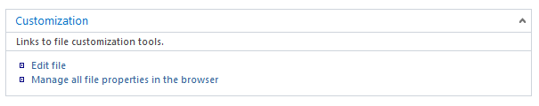

11. On the **seattle_copy(1).master** page under Customization click Edit file.  
  
12. Scroll down to line 38 and click in front of the text **</head>**.  
  
13. Hit **Enter**, to create a space on line 38 as seen in the screen shot below:

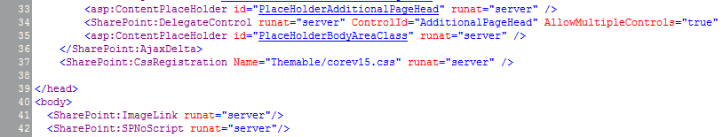

14. Place your cursor in the open space on line 38 and copy/paste the following code:

**<SharePoint:CssRegistration ID="CssRegistration1" name="&lt;% $SPUrl:~sitecollection/style library/custom.css %&gt;" runat="server" after="style.css" />**

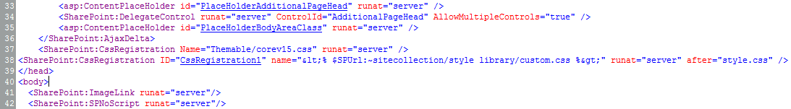

15. In the upper left hand corner click the **save** icon.  We will now create a custom.css file to change the "SharePoint" text.  
  
16. In the left navigation under Site Objects click **All Files**.  
  
17. From All Files locate and click on **Style Library**.

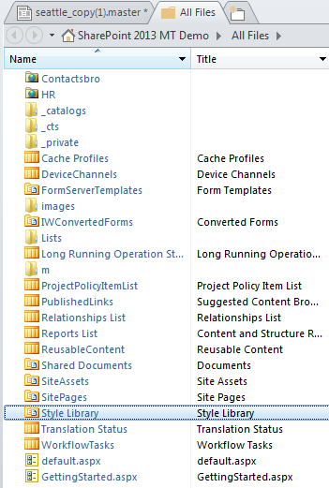

18. From the Style Library page, in the ribbon click **File > CSS**.

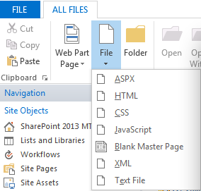

19. Name the file **custom.css**.  
  
20. Click on **custom.css**. (The file you just named)  
  
21. Under Customization click **Edit File**.  
  
22. Click anywhere in the open space and type the following code:

.ms-core-brandingText:after{                 content:"Powered by Rackspace";

}

.ms-core-brandingText{

margin-left: -95px;

}

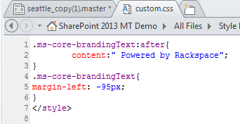

For this example we're changing the "SharePoint" to "Powered by Rackspace." You can replace "Powered by Rackspace" with any text you like. Important to note, the margin-left will need to be adjusted depending on what your text is.

23. In the upper left hand corner click **Save**.  
  
24. In the Manage section click **Check In** then select **Publish major version**.  
  
We're almost done,! The last thing we need to do is apply the newly created master page seattle_copy(1).master to our site.  
  
25. On the left navigation under Site Objects click **Master Pages**.  
  
26. Locate the master page you were editing and click to the right of it to highlight.  
  
27. At the top of the page click on **Set as Custom**, in the ribbon.

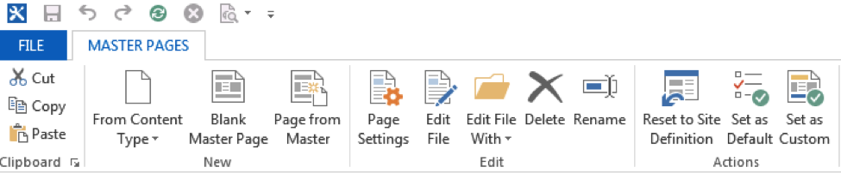

28. Right next to Set as Custom click **Set as Default**.  
  
29. Go to your site and see the change, if you site is already open just refresh the page.

